Exno: 9

Date:

**PROCEDURES AND FUNCTIONS**

**AIM:**

To create a recursive MySQL computing the factorial of a given number using high level programming extension with function.

1. Create a table employee:

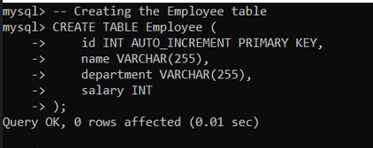

1. Inserting sample data:

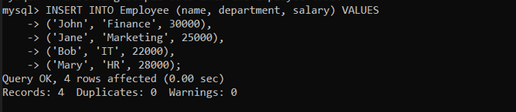

1. 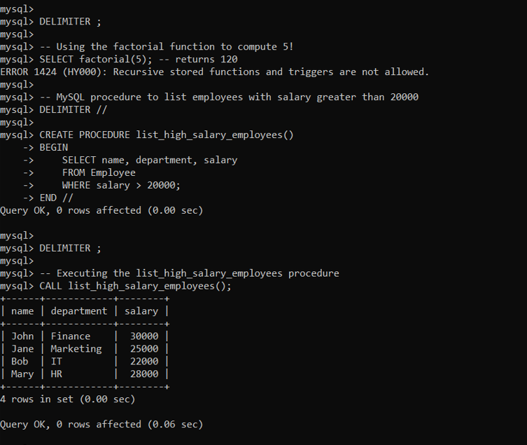

**Result:**

A recursive MySQL computing the factorial of a given number using high level programming extension with function is successfully created.